|  |  |  |  |  |  |
| --- | --- | --- | --- | --- | --- |
| **INPUT No.** | **Penalty Value** | **Number of Lines** | **Time Taken** | **VM Usage** | **Resident Usage** |
| 1 | 5 | 5 | 0.002065 seconds | 5908 kb | 1596 kb |
| 2 | 50 | 5 | 0.001974 seconds | 5908 kb | 1536 kb |
| 3 | 500 | 2 | 0.001329 seconds | 5908 kb | 1464 kb |
| 4 | 5000 | 1 | 0.001584 seconds | 5908 kb | 1540 kb |
| 5 | 50000 | 1 | 0.00139 seconds | 5908 kb | 1536 kb |

**INPUT :**

10

-20 -20

0 6

14 -11

17 7

-7 -14

16 17

-18 19

4 -15

12 11

8 -5

5

**OUTPUT :**

OPT: 25

Number of lines : 5

The lines are :

16 17 17 7

12 11 14 -11

4 -15 8 -5

-7 -14 0 6

-20 -20 -18 19

Time taken: 0.002065 seconds

VM_usage: 5908 kb

Resident_set: 1596 kb

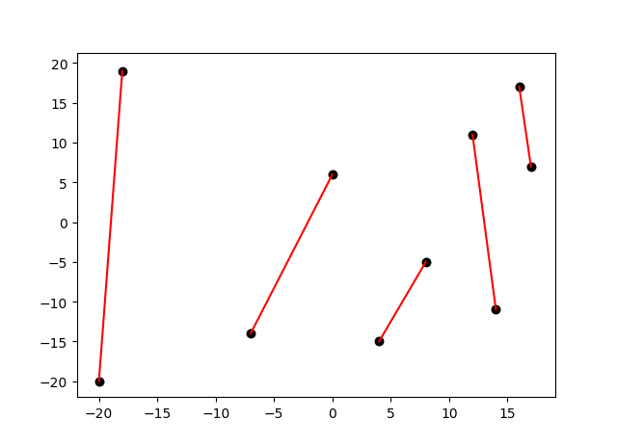

**INPUT :**

10

-20 -20

0 6

14 -11

17 7

-7 -14

16 17

-18 19

4 -15

12 11

8 -5

50

**OUTPUT :**

OPT: 250

Number of lines : 5

The lines are :

16 17 17 7

12 11 14 -11

4 -15 8 -5

-7 -14 0 6

-20 -20 -18 19

Time taken: 0.001974 seconds

VM_usage: 5908 kb

Resident_set: 1536 kb

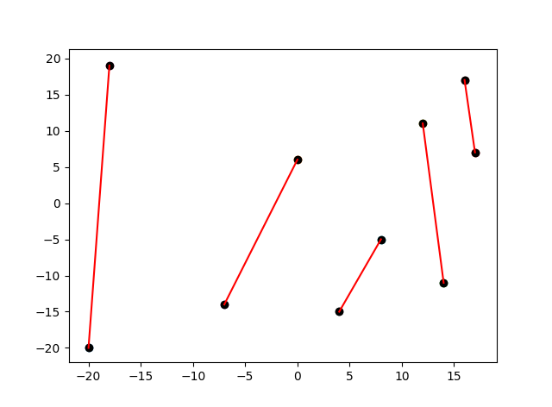

**INPUT :**

10

-20 -20

0 6

14 -11

17 7

-7 -14

16 17

-18 19

4 -15

12 11

8 -5

500

**OUTPUT :**

OPT: 1742.87

Number of lines : 2

The lines are :

-7 -12.4223 17 6.65339

-20 -20 -18 19

Time taken: 0.001329 seconds

VM_usage: 5908 kb

Resident_set: 1464 kb

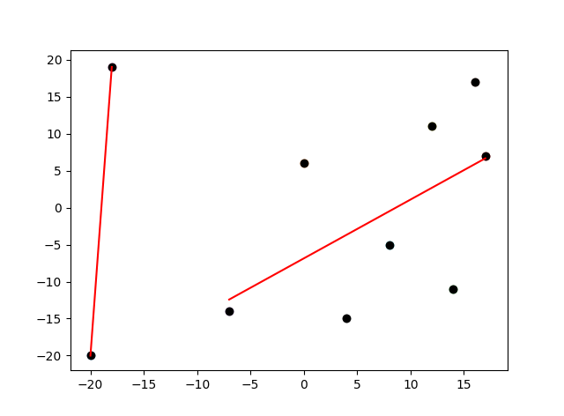

**INPUT :**

10

-20 -20

0 6

14 -11

17 7

-7 -14

16 17

-18 19

4 -15

12 11

8 -5

5000

**OUTPUT :**

OPT: 6705.65

Number of lines : 1

The lines are :

-20 -6.42601 17 3.27586

Time taken: 0.001584 seconds

VM_usage: 5908 kb

Resident_set: 1540 kb

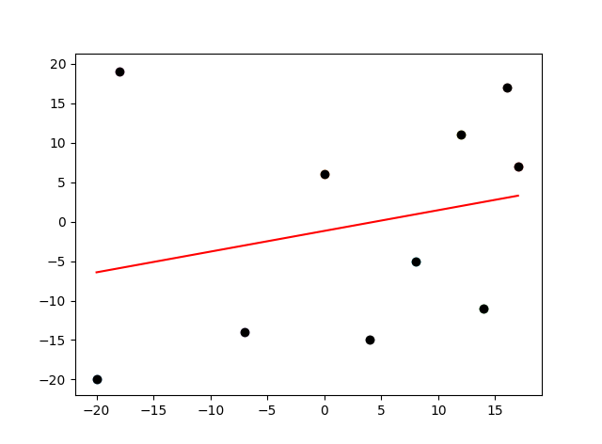

**INPUT :**

10

-20 -20

0 6

14 -11

17 7

-7 -14

16 17

-18 19

4 -15

12 11

8 -5

50000

**OUTPUT :**

OPT: 51705.7

Number of lines : 1

The lines are :

-20 -6.42601 17 3.27586

Time taken: 0.00139 seconds

VM_usage: 5908 kb

Resident_set: 1536 kb

